NATIONAL DIGITAL HERITAGE ARCHIVE PROGRAMME
Content Aggregator
Software Architecture Document

EX-Libris Commons COPY

Version 1.1
26 March 2009
Document Revision History and Control
Version | Date | Author | Version Notes
0.1 | 24/11/08 | Bill Ross | Created version – still under construction.
0.5 | 27/11/08 | Bill Ross | Added class and deployment diagrams
0.6 | 5/12/08 | Bill Ross | Added further detail and logical views
1.0 | 10/12/08 | Bill Ross | First complete version
1.1 | 26/03/09 | Bill Ross | Updates following peer review feedback
1.2 | 5/5/10 | Bill Ross | Updated with minor changes.
CLIO Reference No: # 390561
NLNZ Team Contribution and Review
Name | Position
Kavitha | NDHA Senior Java Developer
Bill Ross | Integration Architect, NDHA Programme
Raghu Pushpakath | Development Team Lead, NDHA Programme
Mike Player | Senior Developer, NDHA Programme
Distribution Group
Name | Position
Steve Knight | NDHA Programme Architect
Mike Kmeic | Manager, Service Development and Support

Introduction

Purpose and Scope
The NDHA/DPS application needs to be integrated into the extended NLNZ application and technical environment. The NDHA/DigiTool – NLNZ Systems Integration Overview document provides an overall context for integration work required and grouped the interfaces with similar requirements into several major categories. These categories include:
- Internal Manual Deposit Application
- Internal Automatic Deposit Applications (WCT, Bulk Loader, File Transfer)
- Collection Management System
- Interval Viewer Applications
- Content Manipulation System
- External Access System
- Common Services
This Software Architecture Document (SAD) describes the architecture and design for the Content Aggregator component that provides integration with the Tapuhi and Voyager resource discovery systems. This document aims to provide the team tasked with the development and support of this tool with sufficient information and references to relevant information to allow them to effectively support it.

Document Evolution
It is not intended that this document be totally complete before development is completed and in fact it is expected to be updated and refined all through the development process as lessons are learnt the design developed, refactored, and finalised.
The aim of this document is to reflect what actually worked and was developed, not what we thought might work before the development was undertaken.
The above said, changes to the document that occur later are expected to be to the more fine grained details than to the high level areas such as Goals and Constraint, Use-cases, and Logical views.

Document Overview
Section | Description
2 | Architectural Representation  This section describes what software architecture is for the current system, and how it is represented. Of the Use-Case, Logical, Deployment, and Implementation Views, it enumerates the views that are necessary, and for each view, explains what types of model elements it contains.
3 | Architectural Goals and Constraints  This section describes the software requirements and objectives that have some significant impact on the architecture, for example, safety, security, privacy, and use of an off-the-shelf product, portability, distribution, and reuse. It also captures the special constraints that may apply: design and implementation strategy, development tools, team structure, schedule, legacy code, and so on.
4 | Use-case View  This section lists use cases or scenarios from the use-case model if they represent some significant, central functionality of the final system, or if they have a large architectural coverage - they exercise many architectural elements, or if they stress or illustrate a specific, delicate point of the architecture.
5 | Logical View  This section shows the architecturally significant components of the application, such as its main components and interfaces.
6 | Deployment View  This section describes one or more physical network (hardware) configurations on which the software is deployed and run. At a minimum for each configuration it should indicate the physical nodes (computers, CPUs) that execute the software, and their interconnections (bus, LAN, point-to-point, and so on.) Also include a mapping of the processes of the Process View onto the physical nodes.
7 | Implementation View  This section describes the overall structure of the implementation model, the decomposition of the software into layers and subsystems in the implementation model, and any architecturally significant components.
8 | Size and Performance  A description of the major dimensioning characteristics of the software that impact the architecture, as well as the target performance constraints.
9 | System Qualities  A description of how the software architecture contributes to all capabilities (other than functionality) of the system: extensibility, reliability, portability, and so on. If these characteristics have special significance, for example safety, security or privacy implications, they should be clearly delineated.

Definitions

Term | Definition
AIP | Archival Information Package – An Information Package, consisting of the Content Information and the associated Preservation Description Information (PDI), which is preserved within an OAIS.
ARC | Internet Archive ARC file format, specifies a method for combining multiple digital resources into an aggregate archival file together with related information
CMS | A system, external to DPS, that is used by a library to fulfil all or some of the following functions:  - Create and maintain catalogue record  - OPAC functionality  - Resource discovery  The CMS’s used by NLNZ are Voyager (ILS) for published material and Tapuhi for unpublished.
DC | Dublin Core - for further information see http://dublincore.org/documents/usageguide/
DIP | Dissemination Information Package - The Information Package, derived from one or more AIPs, received by the Consumer in response to a request to the OAIS.
DPS Archive | The archival storage component of DPS contains both the digital files, stored in a file system, and the relevant metadata (descriptive, technical, provenance etc) stored in a DBMS.
DPS | Digital Preservation System.
EAD | Encoded Archival Description – Standard for encoding archival finding aids using XML. See http://www.loc.gov/ead/.
IID | A unique identifier that is assigned to the Entity when it is first registered by the Archive. The identifier is used as an umbrella identifier for all the Representations that are created for that Entity.
MARC | Machine Readable Cataloguing record. For further information see http://www.loc.gov/marc/.
METS | Metadata Encoding and Transmission Standard - The METS schema is a standard for encoding descriptive, administrative, and structural metadata regarding objects within a digital library, expressed using XML. For further information see http://www.loc.gov/standards/mets/.
OAIS | Open Archival Information System – A reference architecture for a digital information archive developed by Consultative Committee for Space Data Systems. For further information see http://public.ccsds.org/publications/archive/650x0b1.pdf.
OMS | Object Management System – NLNZ system currently used as the main store for digital objects.
OPAC | Online Public Access Catalogue is a computerised online catalogue of the materials held in a library. The library staff and the public can usually access it at computers within the library, or from home via the Internet. Since the mid-1980s, it has replaced the card catalogue in most libraries. Since the mid-1990s, character-based OPAC interfaces are being replaced by Web-based interfaces. OPAC’s are often part of an Integrated Library System.
PDS | Patron Directory Service – the common user management component used across all Ex Libris products.
SIP | Submission Information Package - An Information Package that is delivered by the Producer to the OAIS for use in the construction of one or more AIPs.
SRU | Search/Retrieval via URL – For further information see http://www.loc.gov/standards/sru/
UML | The Unified Modelling Languages is a standard diagramming language for describing software systems. For further information see http://www.uml.org/.
WARC | The WARC (Web ARChive) format specifies a method for combining multiple digital resources into an aggregate archival file together with related information.
WCT | The Web Curator Tool (WCT) is a tool for managing the selective web harvesting process. The WCT Project is a collaborative effort by the National Library of New Zealand and the British Library, initiated by the International Internet Preservation Consortium.  The WCT software is available at http://webcurator.sourceforge.net/ under the terms of the Apache Public License.

References
The following documents and reference material should be read in conjunction with this document.
Document/Reference | Version | Date | Produced By
Use Case Specification UC12: Perform Access Request (Clio # 163003) | 7 |  | NDHA Project
DPS Voyager/Tapuhi DPS Integration Detailed Design (Clio #313116) | Final | Mar 2008 | Ex Libris
NDHA Content Aggregator Deployment  (Clio #313142) | Final | Dec 2008 | NDHA Project
NDHA/DigiTool – NLNZ Systems Integration Overview  (Clio #213352) | 0.4 DRAFT | 28/2/2007 | NDHA Project
NDHA on test2003 – EA, a Sparx Enterprise Architect (EA) UML Model. | N/A | N/A | NDHA Project
Metadata Encoding and Transmission Standard (METS) | Version 1.6 |  | Library of Congress (USA)
METS: Primer and Reference Manual  http://www.loc.gov/standards/mets/METS%20Documentation%20draft%20070310p.pdf | N/A | 10/3/2007 | Library of Congress (USA)
METS Profiles  http://www.loc.gov/standards/mets/mets-profiles.html | 1.2 | 2004 | Library of Congress (USA)
Google Guice Users Guide  http://docs.google.com/View?docid=dd2fhx4z_5df5hw8 | 1.0 | 2008 | Google
NDHA Java Developer Workstation Configuration  (Clio #312832) | Version 1.0 | Dec 2008 | NDHA Project

Architectural Representation
[This section describes what software architecture is for the current system, and how it is represented. Of the Use-Case, Logical, Process, Deployment, and Implementation Views, it enumerates the views that are necessary, and for each view, explains what types of model elements it contains.]
The software architecture for Content Aggregator is concerned with how users of the existing Online Public Access Catalogues (OPACs - Tapuhi and Voyager) can view digital material once they have found it in an OPAC system.
For this integration work the software architecture is concerned with how the key (architecturally significant) use-case of Perform Access Request (UC12) is achieved to meet the business and architectural goals and constraints.
To describe this software architecture the following architectural views of the system will be used, with appropriate use of UML diagrams where appropriate.

Views | Representation
Architectural Goals and Constraint | The architectural goals will be defined as a set of principles expressed in a standard format giving its name, description, rationale, implications, and noted counter-arguments.  The architectural constraints will be listed and described.
Use-case View | UML Use-case diagrams.
Logical View | UML component diagram showing the major architectural components and the major relationships and dependencies between them.
Deployment View | UML deployment diagram showing the computational nodes, their configuration, and the networks elements connection them.
Implementation View | UML class diagram showing the key classes components and their associations. The location of the application source and dependent libraries.
Size and Performance | Data volumes and expected performance figures
Quality | Expected quality metrics

Architectural Principles and Constraints
[This section describes the software requirements and objectives that have some significant impact on the architecture, for example, safety, security, privacy, use of an off-the-shelf product, portability, distribution, and reuse. It also captures the special constraints that may apply: design and implementation strategy, development tools, team structure, schedule, legacy code, and so on.]

Architectural Principles
These software architectural principles exist to guide architectural and design decisions and provide the rationale as to why certain architectural decisions have been made.

Principle Name | The CMS to Digital Object Mapping is Resolved Just-in-time
Description | As there is a one-to-many relationship between a record in an OPAC and digital objects in the DPS. When a request is received by the Content Aggregator, it queries the DPS to get the list of associated digital objects, rather than keep a just-in-case mapping of the relationships between OPAC records and Digital objects.
Rationale | This approach ensures that the Content Aggregator presents an accurate set of current objects, and it also removes the need to provide a set of separate mechanisms and storage to harvest and maintain the relationships in a location independent of the DPS.
Implications | The response time may be slower than if the relationships were stored in a “just-in-case” manner.
Counter Arguments | A “just-in-case” approach could perform faster, however establishing and maintaining a separate data store that contained the CMS record to DPS record relationships would add significant architectural and operational complexity.

Architectural Constraints
Content Aggregator needs to comply with the following architectural constraint.
Constraint Name | Security – Ensure DPS Access Restrictions Applied
Description | Any access restriction is applied at the point when the user tries to access the digital object when they select the link to the object from the list of objects presented by the content aggregator for the CMS record.
Rationale | The DPS is the final arbitrator of access restrictions and therefore must be the component that enforces it.
Implications | There is an existing defect reported against the DPS in which it does not apply the access restrictions against Thumbnail. It is expected that this will be fixed in a future maintenance release soon.

Use-Case View
This section lists use cases or scenarios from the use-case model if they represent some significant, central functionality of the Content Aggregator, or if they have a large architectural coverage - they exercise many architectural elements, or if they stress or illustrate a specific, delicate point of the architecture

Architecturally Significant Use-case
[This section lists use cases or scenarios from the use-case model if they represent some significant, central functionality of the final system, or if they have a large architectural coverage - they exercise many architectural elements, or if they stress or illustrate a specific, delicate point of the architecture.]
The use-cases this document is concerned with is:
- UC12: Perform Access Request
  - Main Flow: Generate Dissemination Information Package (DIP)

When the Access Request is initiated from an existing OPAC system (i.e. Tapuhi or Voyager).

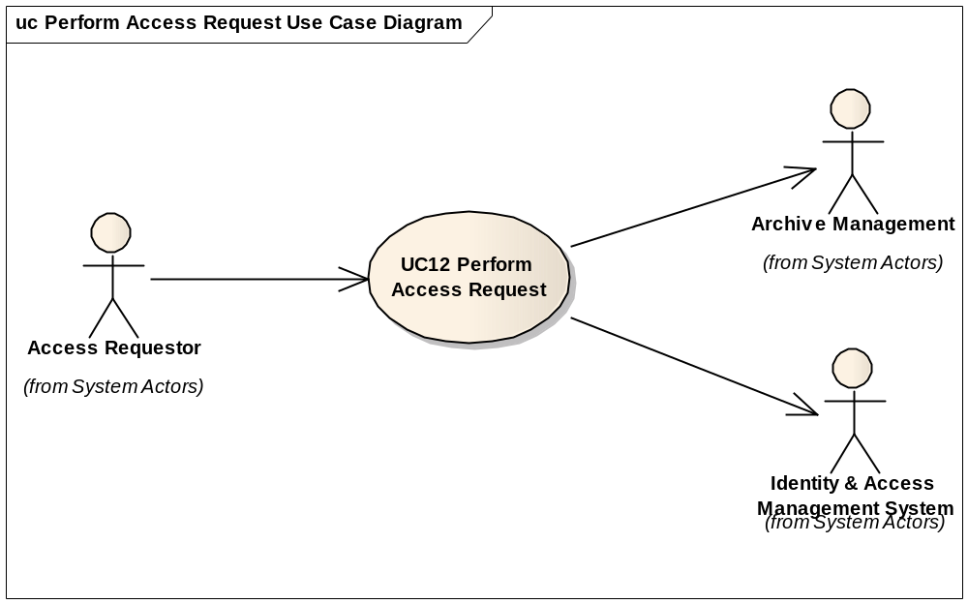

Use-Case Realisations

Content Aggregator – Perform Access Request - Main Flow Overview
On start up the Content Aggregator loads a number of configuration settings which is a pre-condition for realising the Perform Access Request use-case. See section 9.3 - Configurability.
The following UML sequence diagram shows the high-level main flow for an access request made to the content aggregator.
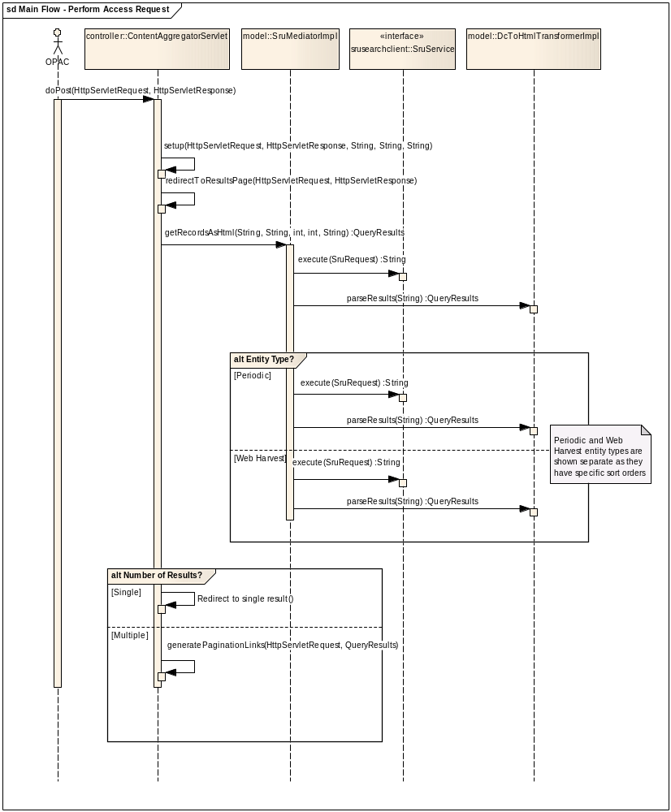

Logical View
[This section describes the architecturally significant parts of the design model, such as its decomposition into subsystems and packages. And for each significant package, its decomposition into classes and class utilities. You should introduce architecturally significant classes and describe their responsibilities, as well as a few very important relationships, operations, and attributes.]

Overview
[This section describes the architecturally significant parts of the design model, such as its decomposition into subsystems and packages. And for each significant package, its decomposition into classes and class utilities. You should introduce architecturally significant classes and describe their responsibilities, as well as a few very important relationships, operations, and attributes.]
[This section describes the architecturally significant parts of the design model, such as its decomposition into subsystems and packages. And for each significant package, its decomposition into classes and class utilities. You should introduce architecturally significant classes and describe their responsibilities, as well as a few very important relationships, operations, and attributes.]
The diagram below shows the architecturally significant components and interfaces of Content Aggregator.
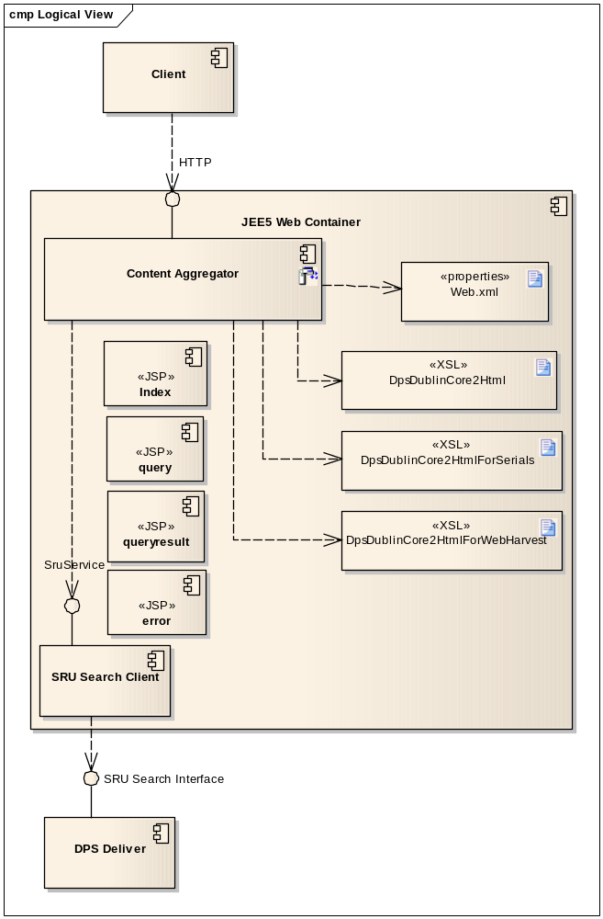

DPS SRU Search Interface Specification

The details of the format of the DPS SRU Search request and response are detailed in the Ex Libris Document Voyager/Tapuhi DPS Integration Detailed Design (Clio reference #313116).
[For each significant package, include a subsection with its name, its brief description, and a diagram with all significant classes and packages contained within the package.
For each significant class in the package, include its name, brief description, and, optionally a description of some of its major responsibilities, operations and attributes.]

[This section describes the system's decomposition into lightweight processes (single threads of control) and heavyweight processes (groupings of lightweight processes). Organise the section by groups of processes that communicate or interact. Describe the main modes of communication between processes, such as message passing, interrupts, and rendezvous.]

Deployment View
[This section describes one or more physical network (hardware) configurations on which the software is deployed and run. At a minimum for each configuration it should indicate the physical nodes (computers, CPUs) that execute the software, and their interconnections (bus, LAN, point-to-point, and so on.) Also include a mapping of the processes of the Process View onto the physical nodes.]
This section describes the physical network and hardware configuration on which the software is deployed and run.
For complete description of deploying the Content Aggregator see the document NDHA Content Aggregator Deployment (Clio #313142).

The UML deployment diagram shows the production deployment on the NDHA Phase I Deliver Server.

Main points to note are:

- The Content Aggregator is deployed as a Java WAR (Web ARchive) file into Tomcat Web Container
- The Delivery Server is deployed in the DMZ
- The Content Aggregator is accessed by external users
- The Content Aggregator depends on the DPS Delivery for the SRU Search

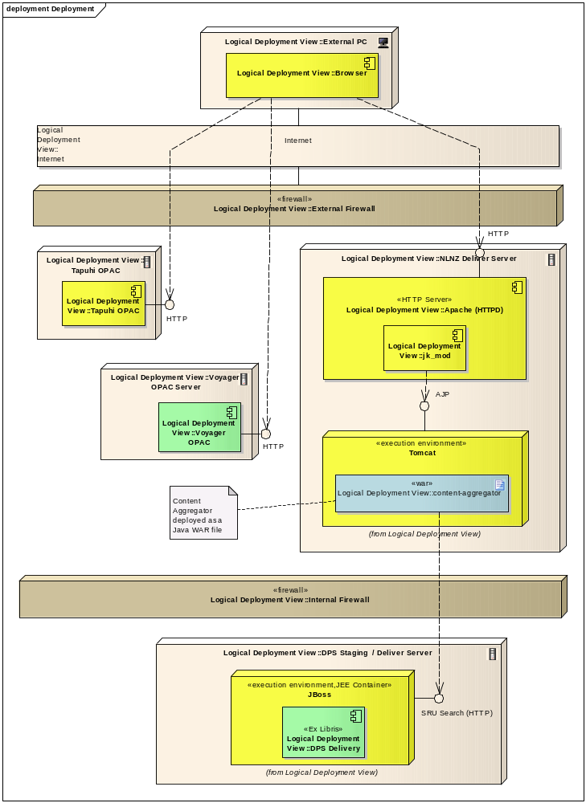

Implementation View
This section describes the overall structure of the implementation model, the decomposition of the software into layers and subsystems in the implementation model, and any architecturally significant components [This section describes the overall structure of the implementation model, the decomposition of the software into layers and subsystems in the implementation model, and any architecturally significant components.]
This section describes the overall structure of the Java implementation

Overview
[This subsection names and defines the various layers and their contents, the rules that govern the inclusion to a given layer, and the boundaries between layers. Include a component diagram that shows the relations between layers. ]
This UML class diagram shows the classes, interfaces, and their relationships for Content Aggregator.

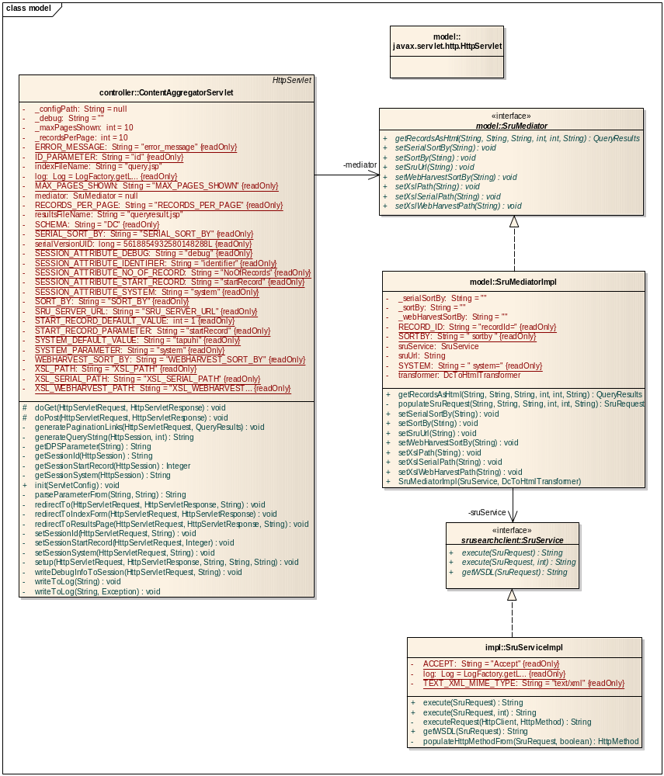

Development Environment and Source Code

- Location of the Code in Subversion
N/A

Size and Performance
[A description of the major dimensioning characteristics of the software that impact the architecture, as well as the target performance constraints.]

Numbers of Requests
The likely total number of Content Aggregator requestors is based on the current OPAC usage adjusted for that proportion of the OPAC content that exists in the DPS.

Submission Volumes
The volume of access requests per system based on current volumes provide from the NetTracker
Requesting System Stream | Average Pages Viewed per Day | Estimated Proportion of content that is Digital (%) | Expected Request Numbers
OPAC1 | 3,749 | 27% | 1,012
OPAC2 | 7,726 | 12% | 927
 |  | TOTAL: | 1,939

Response Times
Response times are expected to be as per the current response time provided by the CMS applications.

System Qualities
[A description of how the software architecture contributes to all capabilities (other than functionality) of the system: extensibility, reliability, portability, and so on. If these characteristics have special significance, for example safety, security or privacy implications, they should be clearly delineated.]
A description of how the software architecture contributes to all capabilities (other than functionality) of the system: extensibility, reliability, portability, and so on. If these characteristics have special significance, for example safety, security or privacy implications, they should be clearly delineated

Portability
The Content Aggregator has been implemented in the Java language and as a Java Servlet using Java SE 6, and the Java EE 5 Servlet API version 2.5, and Java Server Pages (JSP) version 2.1.

The Content Aggregator should be able to be ported to any Java web container that supports the current Java EE 5 level or later.

Security
The enforcement of access restrictions is done by the DPS Delivery module at the point that the user selects a link to the content from what is presented by the Content Aggregator.

Configurability

The following is an example production web.xml configuration file

<!DOCTYPE web-app PUBLIC
"-//Sun Microsystems, Inc.//DTD Web Application 2.3//EN"
"http://java.sun.com/dtd/web-app_2_3.dtd" >

<web-app>
<display-name>DPS Content Aggregator</display-name>

<servlet>
<servlet-name>ContentAggregator</servlet-name>
<servlet-class>nz.govt.natlib.ndha.controller.ContentAggregatorServlet</servlet-class>

<init-param>
<param-name>SRU_SERVER_URL</param-name>

<!--NOTE: DPS sru-->
<!-- UAT. Deployed as content-aggregator -->
<!-- <param-value>http://SRUServerURL/delivery/sru?</param-value> -->
</init-param>

<init-param>
<param-name>XSL_PATH</param-name>

<!--XSL for sru results prefixed with oai_dc-->
<!--<param-value>OAIDublicCore2Html.xsl</param-value>-->

<!--XSL for sru results prefixed with xmns zs and srw_dc-->
<!--<param-value>DublinCore2Html.xsl</param-value>-->

<!--XSL for sru results from DPS-->
<!-- Don't include any path information here - it will be handled by the servlet -->
<param-value>DpsDublinCore2Html.xsl</param-value>
</init-param>

<init-param>
<param-name>SORT_BY</param-name>
<param-value>sortField4/sort.ascending</param-value>
</init-param>

<init-param>
<param-name>XSL_SERIAL_PATH</param-name>
<param-value>DpsDublinCore2HtmlForSerials.xsl</param-value>
</init-param>

<init-param>
<param-name>SERIAL_SORT_BY</param-name>
<param-value>sortField2/sort.descending</param-value>
</init-param>

<init-param>
<param-name>XSL_WEBHARVEST_PATH</param-name>
<param-value>DpsDublinCore2HtmlForWebHarvest.xsl</param-value>
</init-param>

<init-param>
<param-name>WEBHARVEST_SORT_BY</param-name>
<param-value>sortField2/sort.descending</param-value>
</init-param>

<init-param>
<param-name>RECORDS_PER_PAGE</param-name>
<param-value>10</param-value>
</init-param>

<!-- This is for pagination purposes for multiple records -->
<!-- This is the number of pages shown around the current page -->
<!-- e.g. With 12 total pages, at page 6 with a value of 5 would show as: -->
<!-- 1 ... 4 5 6 7 8 ... 12 -->
<!-- With 12 total pages, at page 12 with a value of 5 would show as: -->
<!-- 1 ... 8 9 10 11 12 -->
<!-- Best to make it an odd number as it would look odd otherwise -->
<init-param>
<param-name>MAX_PAGES_SHOWN</param-name>
<param-value>5</param-value>
</init-param>

</servlet>

<servlet>
<servlet-name>Index</servlet-name>
<!-- The full path to a JSP file within the Web Application, relative to the Web Application root directory. -->
<jsp-file>/index.jsp</jsp-file>
</servlet>

<servlet>
<servlet-name>Error</servlet-name>
<jsp-file>/error.jsp</jsp-file>
</servlet>

<servlet>
<servlet-name>QueryResult</servlet-name>
<jsp-file>/queryresult.jsp</jsp-file>
</servlet>

<servlet-mapping>
<servlet-name>ContentAggregator</servlet-name>
<url-pattern>/getIEs</url-pattern>
</servlet-mapping>

</web-app>

